Heat
Heat generated from the nuclear fusion in the Sun, and transported to earth as electromagnetic radiation, is one of the driving forces of life on Earth. Heat is energy transferred from one body, region, or thermodynamic system to another due to thermal contact when the systems are at different temperatures.
Thermodynamically, energy can only be transferred as heat between objects, or regions therein, with different temperatures, as described by the zeroth law of thermodynamics.
This transfer happens spontaneously only in the direction to the colder body, as per the second law of thermodynamics.
The transfer of energy by heat from one object to another object with an equal or higher temperature can happen only with the aid of a heat pump via mechanical work, or by some other similar process in which entropy is increased in the universe in manner that compensates for the decrease of entropy in the cooled object, due to the removal of the heat from it.
For example, heat may be removed against a temperature gradient by spontaneous evaporation of a liquid.
A related term is thermal energy, loosely defined as the energy of a body that increases with its temperature. Thermal energy is also sometimes referred to as heat.

Overview of Heat
Heat flows spontaneously only from systems of higher temperature to systems of lower temperature. When two systems come into thermal contact, they always exchange thermal energy due to the microscopic interactions of their particles.
The first law of thermodynamics states that the energy of an isolated system is conserved. Therefore, to change the energy of a system, energy must be transferred to or from the system. For a closed system, heat and work are the only two mechanisms by which energy can be transferred.
Work performed on a system is, by definition, an energy transfer to the system that is due
Human notions such as hot and cold are relative terms and are generally used to compare one system’s temperature to another or its surroundings.
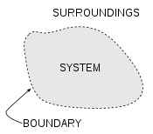

Heat may flow across the boundary of the system and thus change its internal energy.

Heat
Heat is generated from the nuclear fusion in the Sun, and transported to earth as electromagnetic radiation, is one of the driving forces of life on Earth. Heat is energy transferred from one body, region, or thermodynamic system to another due to thermal contact when the systems are at different temperatures.

Definitions
- It is something which may be transferred from one body to another, according to the second law of thermodynamics.
- It is a measurable quantity, and thus treated mathematically.
- It cannot be treated as a substance, because it may be transformed into something that is not a substance, e.g., mechanical work.
- Heat is one of the forms of energy.
Several modern definitions of heat are as follows:
The energy transferred from a high-temperature system to a lower-temperature system is called heat. It flows spontaneously from one system to another caused by a difference in temperature.

Notation and units
As a form of energy heat has the unit joule (J) in the International System of Units (SI). However, in many applied fields in engineering the British Thermal Unit (BTU) and the calorie are often used. The standard unit for the rate of heat transferred is the watt (W), defined as joules per second.
Temperature:
Temperature is a measure of effect of heat energy. It tells us about the degree of hotness or coldness of a body. Increase in volume, change in specific resistance, emission of electro magnetic waves (like Light) are the general effects of the temperature. Based on these principles temperatures are measured.
The principles of temperatures are measurement
Change in volume --- Liquid thermometers -- Mercury thermometers
Change in resistance --- Resistance thermometers ---- digital thermometers
Emission of E/M waves --- Radiation thermometers --- Pyrometer

Comparison of temperature scales
Comparison of temperature scales
Comment | Kelvin  K | Celsius  °C | Fahrenheit  °F
Absolute zero | 0 | −273.15 | −459.67
Lowest recorded natural temperature on Earth  (Vostok, Antarctica - 21 July 1983) | 184 | −89 | −128
Celsius / Fahrenheit's "cross-over" temperature | 233.15 | −40 | –40
Fahrenheit's ice/salt mixture | 255.37 | −17.78 | 0
Water freezes (at standard pressure) | 273.15 | 0 | 32
Average surface temperature on Earth | 288 | 15 | 59
Average human body temperature ² | 310.0 ±0.7 | 36.8 ±0.7 | 98.2 ±1.3
Highest recorded surface temperature on Earth  (Al 'Aziziyah, Libya - 13 September 1922)  But that reading is queried. | 331 | 58 | 136
Water boils (at standard pressure) | 373 | 100 | 212
Gas flame | ~1773 | ~1500 | ~2732
Titanium melts | 1941 | 1668 | 3034
The surface of the Sun | 5800 | 5526 | 9980
¹ The temperature scale is in disuse, and of mere historical interest.
² Normal human body temperature is 36.8 ±0.7 °C, or 98.2 ±1.3 °F. The commonly given value 98.6 °F is simply the exact conversion of the nineteenth-century German standard of 37 °C. Since it does not list an acceptable range, it could therefore be said to have excess (invalid) precision.

Resistance thermometer: Platinum
Resistance thermometers, also called resistance temperature detectors or resistive thermal devices (RTDs), are temperature sensors that exploit the predictable change in electrical resistance of some materials with changing temperature. As they are almost invariably made of platinum, they are often called platinum resistance thermometers (PRTs). They are slowly replacing the use of thermocouples in many industrial applications below 600 °C, due to higher accuracy and repeatability.

Construction
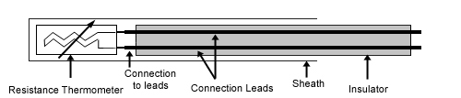
These elements nearly always require insulated leads attached. At temperatures below about 250 °C PVC, silicon rubber or PTFE insulators are used. Above this, glass fibre or ceramic are used. The measuring point, and usually most of the leads, require a housing or protective sleeve, often made of a metal alloy which is chemically inert to the process being monitored.
Calculations:
Resistance thermometer elements can be supplied which function up to 1000 °C. The relation between temperature and resistance is given by the Callendar-Van Dusen equation,
Here, R_{T} is the resistance at temperature T, R₀ is the resistance at 0 °C, and the constants (for an alpha=0.00385 platinum RTD) are
Since the B and C coefficients are relatively small, the resistance changes almost linearly with the temperature.

Internal energy and enthalpy
In the case where the number of particles in the system is constant, the first law of thermodynamics states that the differential change in internal energy dU of a system is given by the differential heat flow δQ into the system minus the differential work δW exerted by the system:^{[note 1]}
,
The differential transfer of heat, δQ_{in}, makes differential contributions, not only to internal energy, but also to the work done by the system:
,
The work done by the system includes boundary work, which causes the boundaries of the system to expand, in addition to other work (e.g. shaft work performed by a compressor fan):
,
is equal to the differential enthalpy change (dH) of the system. Substitution gives:
,
Both enthalpy, H, and internal energy, U, are state functions. In cyclical processes, such as the operation of a heat engine, state functions return to their initial values. Thus, the differentials for enthalpy and energy are exact differentials, which are dH and dU, respectively. The symbol for exact differentials is the lowercase letter d.
In contrast, neither Q nor W represents the state of the system (i.e. they need not return to their original values when returning to same step in the following cycle). Thus, the infinitesimal expressions for heat and work are inexact differentials, δQ and δW, respectively. The lowercase Greek letter delta, δ, is the symbol for inexact differentials. The integral of any inexact differential over the time it takes to leave and return to the same thermodynamic state does not necessarily equal zero. However, for processes involving no change in volume (i.e. dV = 0), applied magnetic field, or other external parameters (i.e. δW_{out} = 0 and δW_{in} = 0), δQ forms the exact differential, 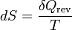, wherein the following relation applies:
dU = TdS = δQ_{rev}.
Likewise, for an isentropic process (i.e. δQ = 0 and dS = 0), δW forms the exact differential, 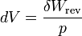, wherein the following relation applies:
dU = − pdV = − δW_{rev},

Path-independent examples for an ideal gas
For a simple compressible system such as an ideal gas inside a piston, the internal energy change ΔU at constant volume and the enthalpy change ΔH at constant pressure are modeled by separate heat capacity values, which are C_{v} and C_{p}, respectively.
Constrained to have constant volume, the heat, Q, required to change its temperature from an initial temperature, T₀, to a final temperature, T_{f}, is given by this formula:
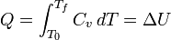
Removing the volume constraint and allowing the system to expand or contract at constant pressure, the heat, Q, required to change its temperature from an initial temperature, T₀, to a final temperature, T_{f}, is given by this formula:
Note that when integrating an exact differential (e.g. dU), the lowercase letter d is substituted for Δ (e.g. ΔU), and when integrating an inexact differential (e.g. δW_{boundary}), the lowercase Greek letter δ is removed with no replacement (e.g. W_{boundary}).

Incompressible substances
For incompressible substances, such as solids and liquids, the distinction between the two types of heat capacity (i.e. C_{p} which is based on constant pressure and C_{v} which is based on constant volume) disappears, as no work is performed.

Latent and sensible heat
In a 1847 lecture entitled On Matter, Living Force, and Heat, James Prescott Joule characterized the terms latent heat and sensible heat as components of heat each effecting distinct physical phenomena, namely the potential and kinetic energy of particles, respectively.^{[8]} He described latent energy as the energy of interaction in a given configuration of particles, i.e. a form of potential energy, and the sensible heat as an energy affecting the thermal energy, which he called the living force.
Latent heat is the heat released or absorbed by a chemical substance or a thermodynamic system during a change of state that occurs without a change in temperature. Such a process may be a phase transition, such as the melting of ice or the boiling of water.^{[9][10]} The term was introduced around 1750 by Joseph Black as derived from the Latin latere (to lie hidden), characterizing its effect as not being directly measurable with a thermometer.
Sensible heat, in contrast to latent heat, is the heat exchanged by a thermodynamic system that has as its sole effect a change of temperature.^{[11]} Sensible heat therefore only increases the thermal energy of a system.

Specific heat
Specific heat, also called specific heat capacity, is defined as the amount of energy that has to be transferred to or from one unit of mass (kilogram) or amount of substance (mole) to change the system temperature by one degree. Specific heat is a physical property, which means that it depends on the substance under consideration and its state as specified by its properties.
The specific heats of monatomic gases (e.g., helium) are nearly constant with temperature. Diatomic gases such as hydrogen display some temperature dependence, and triatomic gases (e.g., carbon dioxide) still more.

Entropy
In 1856, German physicist Rudolf Clausius defined the second fundamental theorem (the second law of thermodynamics) in the mechanical theory of heat (thermodynamics): "if two transformations which, without necessitating any other permanent change, can mutually replace one another, be called equivalent, then the generations of the quantity of heat Q from work at the temperature T, has the equivalence-value:"^{[12][13]}
In 1865, he came to define this ratio as entropy symbolized by S, such that, for a closed, stationary system:
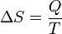
and thus, by reduction, quantities of heat δQ (an inexact differential) are defined as quantities of TdS (an exact differential):
In other words, the entropy function S facilitates the quantification and measurement of heat flow through a thermodynamic boundary.
To be precise, this equality is only valid, if the heat δQ is applied reversibly. If, in contrast, irreversible processes are involved, e.g. some sort of friction, then instead of the above equation one has
This is the second law of thermodynamics.
Thermoelectric effect: The thermoelectric effect is the direct conversion of temperature differences to electric voltage and vice-versa. A thermoelectric device creates a voltage when there is a different temperature on each side. Conversely, when a voltage is applied to it, it creates a temperature difference. At the atomic scale, an applied temperature gradient causes charged carriers in the material to diffuse from the hot side to the cold side, similar to a classical gas that expands when heated; hence inducing a thermal current.
This effect can be used to generate electricity, measure temperature or change the temperature of objects. Because the direction of heating and cooling is determined by the polarity of the applied voltage, thermoelectric devices are efficient temperature controllers.

Thermoelectricity is a two-way process. It can refer either to the way a temperature difference between one side of a material and the other can produce electricity, or to the reverse: the way applying an electric current through a material can create a temperature difference between its two sides, which can be used to heat or cool things without combustion or moving parts.
Thermoelectricity, direct conversion of heat into electric energy, or vice versa. The term is generally restricted to the irreversible conversion of electricity into heat described by the English physicist James P. Joule and to three reversible effects named for Seebeck, Peltier, and Thomson, their respective discoverers. According to Joule's law, a conductor carrying a current generates heat at a rate proportional to the product of the resistance (R) of the conductor and the square of the current (I).
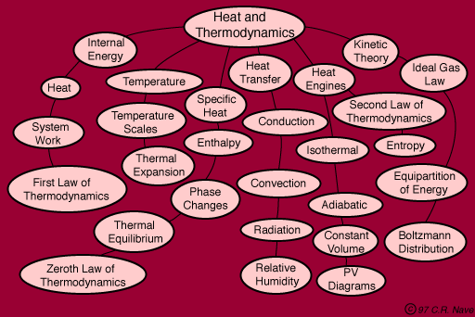

The Second Law of Thermodynamics
All processes manifest a tendency toward decay and disintegration, with a net increase in what is called the entropy, or state of randomness or disorder, of the system.
The Second Law (Law of Energy Decay) states that every system left to its own devices always tends to move from order to disorder, its energy tending to be transformed into lower levels of availability, finally reaching the state of complete randomness and unavailability for further work.

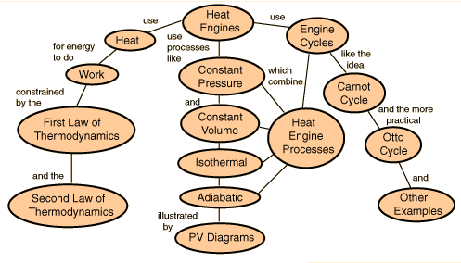

Heat Flow to Hotter Region
Although internal energy will not spontaneously flow from a cold region to a hot region, it can be forced to do so by doing work on the system. Refrigerators and heat pumps are examples of heat engines which cause energy to be transferred from a cold area to a hot area. Usually this is done with the aid of a phase change, i.e., a refrigerant liquid is forced to evaporate and extract energy from the cold area. Then it is compressed and forced to condense in the hot area, dumping its heat of vaporization into the hot area.
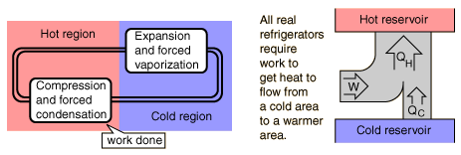

Refrigerator
If you place your hand behind an operating refrigerator, you will notice that this area is warmer than the room temperature. Or you may notice that the refrigerator blows warm air on your feet as you stand in front of it. Yet the interior of the freezing compartment is very cold! The refrigerator is taking energy from the freezing compartment, making it colder, and exhausting that heat to the room, making it warmer.
A refrigerator is a heat engine in which work is done on a refrigerant substance in order to collect energy from a cold region and exhaust it in a higher temperature region, therby further cooling the cold region.
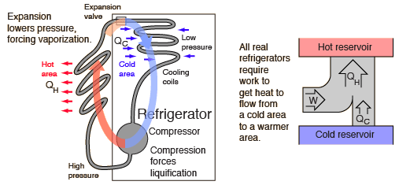
Refrigerators have made use of fluorinated hydrocarbons with trade names like Freon-12, Freon-22, etc. which can be forced to evaporate and then condense by successively lowering and raising the pressure. They can therefore "pump" energy from a cold region to a hotter region by extracting the heat of vaporization from the cold region and dumping it in the hotter region outside the refrigerator. The statements about refrigerators apply to air conditioners and heat pumps, which embody the same principles.
Although this process works very well and has been in place for decades, the bad news about it is that fluorinated hydrocarbons released into the atmosphere are potent agents for the destruction of the ozone in the upper atmosphere. Therefore tighter and tighter restrictions are being placed on their use.

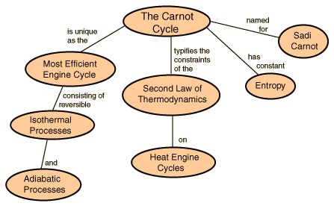

Carnot Cycle
The most efficient heat engine cycle is the Carnot cycle, consisting of two isothermal processes and two adiabatic processes. The Carnot cycle can be thought of as the most efficient heat engine cycle allowed by physical laws. When the second law of thermodynamics states that not all the supplied heat in a heat engine can be used to do work, the Carnot efficiency sets the limiting value on the fraction of the heat which can be so used.
In order to approach the Carnot efficiency, the processes involved in the heat engine cycle must be reversible and involve no change in entropy. This means that the Carnot cycle is an idealization, since no real engine processes are reversible and all real physical processes involve some increase in entropy.
Top of Form
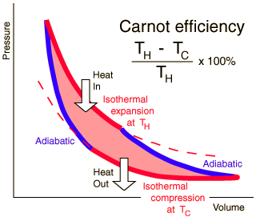

Bottom of Form
The conceptual value of the Carnot cycle is that it establishes the maximum possible efficiency for an engine cycle operating between T_{H} and T_{C}. It is not a practical engine cycle because the heat transfer into the engine in the isothermal process is too slow to be of practical value. As Schroeder puts it "So don't bother installing a Carnot engine in your car; while it would increase your gas mileage, you would be passed on the highway by pedestrians."

Entropy and the Carnot Cycle
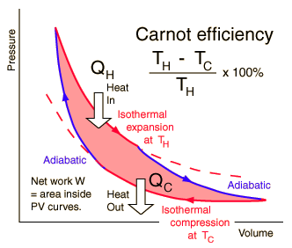 | The efficiency of a heat engine cycle is given by  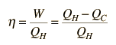  For the ideal case of the Carnot cycle, this efficiency can be written  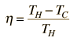
Using these two expressions together
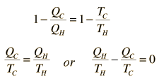
If we take Q to represent heat added to the system, then heat taken from the system will have a negative value. For the Carnot cycle
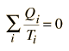
which can be generalized as an integral around a reversible cycle
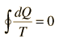 | Clausius Theorem
For any part of the heat engine cycle, this can be used to define a change in entropy S for the system
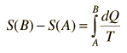
or in differential form at any point in the cycle
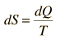
For any irreversible process, the efficiency is less than that of the Carnot cycle. This can be associated with less heat flow to the system and/or more heat flow out of the system. The inevitable result is
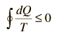 | Clausius Inequality
Any real engine cycle will result in more entropy given to the environment than was taken from it, leading to an overall net increase in entropy.
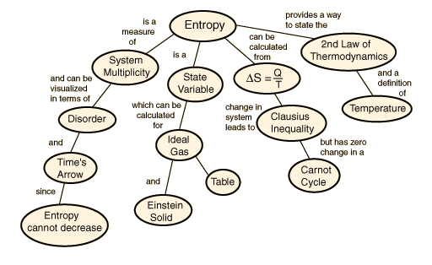

Resistance thermometer: Platinum
Resistance thermometers, also called resistance temperature detectors or resistive thermal devices (RTDs), are temperature sensors that exploit the predictable change in electrical resistance of some materials with changing temperature. As they are almost invariably made of platinum, they are often called platinum resistance thermometers (PRTs). They are slowly replacing the use of thermocouples in many industrial applications below 600 °C, due to higher accuracy and repeatability.

Construction

These elements nearly always require insulated leads attached. At temperatures below about 250 °C PVC, silicon rubber or PTFE insulators are used. Above this, glass fibre or ceramic are used. The measuring point, and usually most of the leads, require a housing or protective sleeve, often made of a metal alloy which is chemically inert to the process being monitored.
Calculations:
Resistance thermometer elements can be supplied which function up to 1000 °C. The relation between temperature and resistance is given by the Callendar-Van Dusen equation,
Here, R_{T} is the resistance at temperature T, R₀ is the resistance at 0 °C, and the constants (for an alpha=0.00385 platinum RTD) are
Since the B and C coefficients are relatively small, the resistance changes almost linearly with the temperature.

Kinetic theory

The temperature of an ideal monatomic gas is a measure of the average kinetic energy of its atoms. The atoms have a certain, average speed, slowed down here two trillion fold from room temperature.
The kinetic theory of gases describes a gas as a large number of small particles (atoms or molecules), all of which are in constant, random motion. The rapidly moving particles constantly collide with each other and with the walls of the container. Kinetic theory explains macroscopic properties of gases, such as pressure, temperature, or volume, by considering their molecular composition and motion. Essentially, the theory posits that pressure is due not to static repulsion between molecules, as was Isaac Newton's conjecture, but due to collisions between molecules moving at different velocities.
While the particles making up a gas are too small to be visible, the jittering motion of pollen grains or dust particles which can be seen under a microscope, known as Brownian motion, results directly from collisions between the particle and gas molecules. As pointed out by Albert Einstein in 1905, this experimental evidence for kinetic theory is generally seen as having confirmed the existence of atoms and molecules.

Postulates
The theory for ideal gases makes the following assumptions:
- The gas consists of very small particles. This smallness of their size is such that the total volume of the individual gas molecules added up is negligible compared to the volume of the container. This is equivalent to stating that the average distance separating the gas particles is large compared to their size.
- These particles have the same mass.
- The number of molecules is so large that statistical treatment can be applied.
- These molecules are in constant, random and rapid motion.
- The rapidly moving particles constantly collide among themselves and with the walls of the container. All these collisions are perfectly elastic. This means, the molecules are considered to be perfectly spherical in shape, and elastic in nature.
- Except during collisions, the interactions among molecules are negligible. (That is, they exert no forces on one another.)
This implies:
1. Relativistic effects are negligible.
2. Quantum-mechanical effects are negligible. This means that the inter-particle distance is much larger than the thermal de Broglie wavelength and the molecules are treated as classical objects.
3. Because of the above two, their dynamics can be treated classically. This means, the equations of motion of the molecules are time-reversible.
- The average kinetic energy of the gas particles depends only on the temperature of the system.
- The time during collision of molecule with the container's wall is negligible as compared to the time between successive collisions.
More modern developments relax these assumptions and are based on the Boltzmann equation. These can accurately describe the properties of dense gases, because they include the volume of the molecules. The necessary assumptions are the absence of quantum effects, molecular chaos and small gradients in bulk properties. Expansions to higher orders in the density are known as virial expansions. The definitive work is the book by Chapman and Enskog but there have been many modern developments and there is an alternative approach developed by Grad based on moment expansions.^{[citation needed]} In the other limit, for extremely rarefied gases, the gradients in bulk properties are not small compared to the mean free paths. This is known as the Knudsen regime and expansions can be performed in the Knudsen number.

Properties

Pressure and kinetic energy
Pressure is explained by kinetic theory as arising from the force exerted by molecules or atoms impacting on the walls of a container. Consider a gas of N molecules, each of mass m, enclosed in a cuboidal container of volume V=L³. When a gas molecule collides with the wall of the container perpendicular to the x coordinate axis and bounces off in the opposite direction with the same speed (an elastic collision), then the momentum lost by the particle and gained by the wall is:
where v_{x} is the x-component of the initial velocity of the particle.
The particle impacts one specific side wall once every
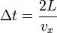
(where L is the distance between opposite walls).
The force due to this particle is:
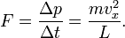
The total force on the wall is
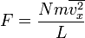
where the bar denotes an average over the N particles. Since the assumption is that the particles move in random directions, we will have to conclude that if we divide the velocity vectors of all particles in three mutually perpendicular directions, the average value along each direction must be same. (This does not mean that each particle always travel in 45 degrees to the coordinate axes.)
.
We can rewrite the force as
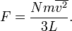
This force is exerted on an area L². Therefore the pressure of the gas is
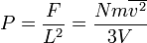
where V=L³ is the volume of the box. The fraction n=N/V is the number density of the gas (the mass density ρ=nm is less convenient for theoretical derivations on atomic level). Using n, we can rewrite the pressure as
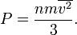
This is a first non-trivial result of the kinetic theory because it relates pressure, a macroscopic property, to the average (translational) kinetic energy per molecule 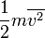which is a microscopic property.

Temperature and kinetic energy
From the ideal gas law
(1)
where is the Boltzmann constant, and the absolute temperature,
and from the above result 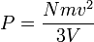we have 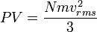
we have 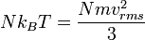
then the temperature takes the form
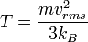 | (2)
which leads to the expression of the kinetic energy of a molecule
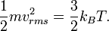
The kinetic energy of the system is N times that of a molecule 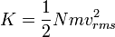
The temperature becomes
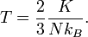 | (3)
Eq.(3)₁ is one important result of the kinetic theory: The average molecular kinetic energy is proportional to the absolute temperature. From Eq.(1) and Eq.(3)₁, we have
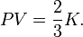 | (4)
Thus, the product of pressure and volume per mole is proportional to the average (translational) molecular kinetic energy.
Eq.(1) and Eq.(4) are called the "classical results", which could also be derived from statistical mechanics; for more details, see .^{[1]}
Since there are degrees of freedom in a monoatomic-gas system with particles, the kinetic energy per degree of freedom per molecule is
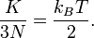 | (5)
In the kinetic energy per degree of freedom, the constant of proportionality of temperature is 1/2 times Boltzmann constant. In addition to this, the temperature will decrease when the pressure drops to a certain point. This result is related to the equipartition theorem.
As noted in the article on heat capacity

, diatomic gases should have 7 degrees of freedom, but the lighter gases act as if they have only 5.
Thus the kinetic energy per kelvin (monatomic ideal gas) is:
- per mole: 12.47 J
- per molecule: 20.7 yJ = 129 μeV.
At standard temperature (273.15 K), we get:
- per mole: 3406 J
- per molecule: 5.65 zJ = 35.2 meV.

Collisions with container
One can calculate the number of atomic or molecular collisions with a wall of a container per unit area per unit time.
Assuming an ideal gas, a derivation^{[2]} results in an equation for total number of collisions per unit time per area:
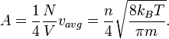

Speed of molecules
From the kinetic energy formula it can be shown that
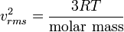
with v in m/s, T in kelvins, and R is the gas constant. The molar mass is given as kg/mol. The most probable speed is 81.6% of the rms speed, and the mean speeds 92.1% (distribution of speeds

Three postulates of the Kinetic Theory
- Gases consist of particles (atoms or molecules) in continuous, random motion.
- Collisions between gas particles are elastic.
- The average energy of translational motion of a gas particle is directly proportional to temperature.
In addition to the postulates above, it is assumed that the volumes of the particles are negligible as compared to container volume and attractive forces between particles are neglected.
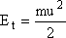
E_{t} = average kinetic energy of translation
KE_{avg}
m = mass of the particle
u = average velocity of the particle
from the third postulate we can formulate
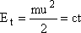
T = temperature in Kelvin, c = constant which has the same value for all gases.
- Average Speed of Gas particles (find u)
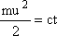
c = constant = 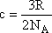
R = gas constant, N_{A} = Avogadro's #
substituting for c
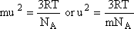
mass times moles (N_{A}) equals Molar Mass (MM), substituting MM and solving for u gives
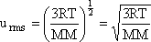
using this last equation we can solve for an individual gas particle's speed rms = root mean square, which is the average square root of the speed of the individual particles.
Use R = 8.3148 , in order for the units to come out in m/s
- Grahm's Law
effusion - the flow of gas particles through a small opening or pinhole in a container.
diffusion - random motion of gas particles.
formulas:
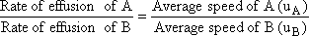
if the two gases are at the same temperature then:
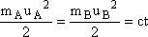
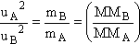
Experimentally usually measure the time for effusion to occur, this time is an inverse of the effusion rate (lower times-faster effusion rates)
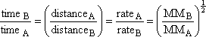
this equation was used for the separation of U₂₃₈ during WWII by effusion principles.
Real Gases
Deviate at least slightly from Ideal Gas Law because of two factors:
- gas molecules attract one another
- gas molecules occupy a finite volume
Both of these factors are neglected in the Ideal Gas law. Both increase in importance when molecules are close together (high P, low T)
van der Walls equation
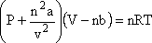
corrects for the attraction between molecules.
nb corrects for the volume of gas molecules

First Law of Thermodynamics
The first law of thermodynamics is the application of the conservation of energy principle to heat and thermodynamic processes:
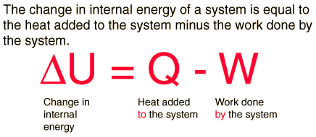

The first law makes use of the key concepts of internal energy, heat, and system work. It is used extensively in the discussion of heat engines. The standard unit for all these quantities would be the joule, although they are sometimes expressed in calories or BTU.
It is typical for chemistry texts to write the first law as ΔU=Q+W. It is the same law, of course - the thermodynamic expression of the conservation of energy principle. It is just that W is defined as the work done on the system instead of work done by the system. In the context of physics, the common scenario is one of adding heat to a volume of gas and using the expansion of that gas to do work, as in the pushing down of a piston in an internal combustion engine. In the context of chemical reactions and process, it may be more common to deal with situations where work is done on the system rather than by it.

Enthalpy
Four quantities called "thermodynamic potentials" are useful in the chemical thermodynamics of reactions and non-cyclic processes. They are internal energy, the enthalpy, the Helmholtz free energy and the Gibbs free energy. Enthalpy is defined by
H = U + PV
where P and V are the pressure and volume, and U is internal energy. Enthalpy is then a precisely measurable state variable, since it is defined in terms of three other precisely definable state variables. It is somewhat parallel to the first law of thermodynamics for a constant pressure system
Q = ΔU + PΔV since in this case Q=ΔH
It is a useful quantity for tracking chemical reactions. If as a result of an exothermic reaction some energy is released to a system, it has to show up in some measurable form in terms of the state variables. An increase in the enthalpy H = U + PV might be associated with an increase in internal energy which could be measured by calorimetry, or with work done by the system, or a combination of the two.
The internal energy U might be thought of as the energy required to create a system in the absence of changes in temperature or volume. But if the process changes the volume, as in a chemical reaction which produces a gaseous product, then work must be done to produce the change in volume. For a constant pressure process the work you must do to produce a volume change ΔV is PΔV. Then the term PV can be interpreted as the work you must do to "create room" for the system if you presume it started at zero volume.

System Work
When work is done by a thermodynamic system, it is ususlly a gas that is doing the work. The work done by a gas at constant pressure is:
Example | 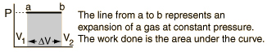
For non-constant pressure, the work can be visualized as the area under the pressure-volume curve which represents the process taking place. The more general expression for work done is:
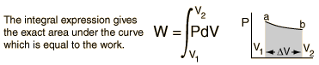

Work done by a system decreases the internal energy of the system, as indicated in the First Law of Thermodynamics. System work is a major focus in the discussion of heat engines

The First Law of Thermodynamics is a balance of the various forms of energy as they pertain to the specified thermodynamic system (control volume) being studied.
First Law of Thermodynamics - The First Law of Thermodynamics states:
Energy can neither be created nor destroyed, only altered in form. For any system, energy transfer is associated with mass and energy crossing the control boundary, external work and/or heat crossing the boundary, and the change of stored energy within the control volume. The mass flow of fluid is associated with the kinetic, potential, internal, and "flow" energies that affect the overall energy balance of the system. The exchange of external work and/or heat complete the energy balance. The First Law of Thermodynamics is referred to as the Conservation of Energy principle, meaning that energy can neither be created nor destroyed, but rather transformed into various forms as the fluid within the control volume is being studied. The energy balance spoken of here is maintained within the system being studied. The system is a region in space (control volume) through which the fluid passes.
The second law of thermodynamics is an expression of the tendency that over time, differences in temperature, pressure, and chemical potential equilibrate in an isolated physical system. From the state of thermodynamic equilibrium, the law deduced the principle of the increase of entropy and explains the phenomenon of irreversibility in nature. The second law declares the impossibility of machines that generate usable energy from the abundant internal energy of nature by processes called perpetual motion of the second kind.
The second law may be expressed in many specific ways, but the first formulation is credited to the German scientist Rudolf Clausius. The law is usually stated in physical terms of impossible processes. In classical thermodynamics, the second law is a basic postulate applicable to any system involving measurable heat transfer, while in statistical thermodynamics, the second law is a consequence of unitarity in quantum theory. In classical thermodynamics, the second law defines the concept of thermodynamic entropy, while in statistical mechanics entropy is defined from information theory, known as the Shannon entropy.
Thermodynamics
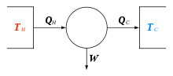

Description
The first law of thermodynamics provides the basic definition of thermodynamic energy, also called internal energy, associated with all thermodynamic systems, but unknown in mechanics, and states the rule of conservation of energy in nature.
However, the concept of energy in the first law does not account for the observation that natural processes have a preferred direction of progress. For example, spontaneously, heat always flows to regions of lower temperature, never to regions of higher temperature without external work being performed on the system. The first law is completely symmetrical with respect to the initial and final states of an evolving system. The key concept for the explanation of this phenomenon through the second law of thermodynamics is the definition of a new physical property, the entropy.
A change in the entropy (S) of a system is the infinitesimal transfer of heat (Q) to a closed system driving a reversible process, divided by the equilibrium temperature (T) of the system.^{[1]}
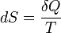
The entropy of an isolated system that is in equilibrium is constant and has reached its maximum value.
Empirical temperature and its scale is usually defined on the principles of thermodynamics equilibrium by the zeroth law of thermodynamics.^{[2]} However, based on the entropy, the second law permits a definition of the absolute, thermodynamic temperature, which has its null point at absolute zero.^{[3]}
The second law of thermodynamics may be expressed in many specific ways,^{[4]} the most prominent classical statements^{[3]} being the original statement by Rudolph Clausius (1850), the formulation by Lord Kelvin (1851), and the definition in axiomatic thermodynamics by Constantin Carathéodory (1909). These statements cast the law in general physical terms citing the impossibility of certain processes. They have been shown to be equivalent.

Clausius statement
German scientist Rudolf Clausius is credited with the first formulation of the second law, now known as the Clausius statement:^{[4]}
No process is possible whose sole result is the transfer of heat from a body of lower temperature to a body of higher temperature.^{[note 1]}
Spontaneously, heat cannot flow from cold regions to hot regions without external work being performed on the system, which is evident from ordinary experience of refrigeration, for example. In a refrigerator, heat flows from cold to hot, but only when forced by an external agent, a compressor.

Kelvin statement
Lord Kelvin expressed the second law in another form. The Kelvin statement expresses it as follows:^{[4]}
No process is possible in which the sole result is the absorption of heat from a reservoir and its complete conversion into work.
This means it is impossible to extract energy by heat from a high-temperature energy source and then convert all of the energy into work. At least some of the energy must be passed on to heat a low-temperature energy sink. Thus, a heat engine with 100% efficiency is thermodynamically impossible. This also means that it is impossible to build solar panels that generate electricity solely from the infrared band of the electromagnetic spectrum without consideration of the temperature on the other side of the panel (as is the case with conventional solar panels that operate in the visible spectrum).
Note that it is possible to convert heat completely into work, such as the isothermal expansion of ideal gas. However, such a process has an additional result. In the case of the isothermal expansion, the volume of the gas increases and never goes back without outside interference.

Principle of Carathéodory
Constantin Carathéodory formulated thermodynamics on a purely mathematical axiomatic foundation. His statement of the second law is known as the Principle of Carathéodory, which may be formulated as follows:^{[5]}
In every neighborhood of any state S of an adiabatically isolated system there are states inaccessible from S.^{[6]}
With this formulation he described the concept of adiabatic accessibility for the first time and provided the foundation for a new subfield of classical thermodynamics, often called geometrical thermodynamics.

Equivalence of the statements
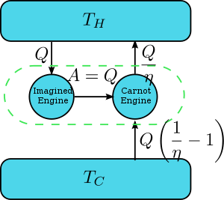
Derive Kelvin Statement from Clausius Statement
Suppose there is an engine violating the Kelvin statement: i.e.,one that drains heat and converts it completely into work in a cyclic fashion without any other result. Now pair it with a reversed Carnot engine as shown by the graph. The net and sole effect of this newly created engine consisting of the two engines mentioned is transferring heat 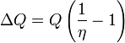from the cooler reservoir to the hotter one, which violates the Clausius statement. Thus the Clausius statement implies the Kelvin statement. We can prove in a similar manner that the Kelvin statement implies the Clausius statement, or, in a word, the two are equivalent.

Corollaries

Perpetual motion of the second kind
Main article: perpetual motion
Prior to the establishment of the Second Law, many people who were interested in inventing a perpetual motion machine had tried to circumvent the restrictions of First Law of Thermodynamics by extracting the massive internal energy of the environment as the power of the machine. Such a machine is called a "perpetual motion machine of the second kind". The second law declared the impossibility of such machines.

Carnot theorem
Carnot's theorem is a principle that limits the maximum efficiency for any possible engine. The efficiency solely depends on the temperature difference between the hot and cold thermal reservoirs. Carnot's theorem states:
- All irreversible heat engines between two heat reservoirs are less efficient than a Carnot engine operating between the same reservoirs.
- All reversible heat engines between two heat reservoirs are equally efficient with a Carnot engine operating between the same reservoirs.
Historically, the principle was based on the invalid caloric theory and preceded the establishment of the second law;^{[7]} however, it has since been recognized as a result of the second law.

Clausius theorem
The Clausius theorem (1854) states that in a cyclic process
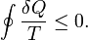
The equality holds in the reversible case^{[8]} and the '<' is in the irreversible case. The reversible case is used to introduce the state function entropy. This is because in cyclic processes the variation of a state function is zero.

Thermodynamic temperature
Main article: Thermodynamic temperature
For an arbitrary heat engine, the efficiency is:
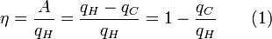
where A is the work done per cycle. Thus the efficiency depends only on q_{C}/q_{H}.
Carnot's theorem states that all reversible engines operating between the same heat reservoirs are equally efficient. Thus, any reversible heat engine operating between temperatures T₁ and T₂ must have the same efficiency, that is to say, the effiency is the function of temperatures only: 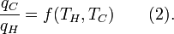
In addition, a reversible heat engine operating between temperatures T₁ and T₃ must have the same efficiency as one consisting of two cycles, one between T₁ and another (intermediate) temperature T₂, and the second between T₂ andT₃. This can only be the case if
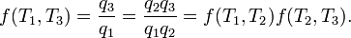
Now consider the case where T₁ is a fixed reference temperature: the temperature of the triple point of water. Then for any T₂ and T₃,
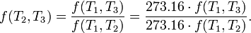
Therefore if thermodynamic temperature is defined by
then the function f, viewed as a function of thermodynamic temperature, is simply
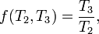
and the reference temperature T₁ will have the value 273.16. (Of course any reference temperature and any positive numerical value could be used—the choice here corresponds to the Kelvin scale.)

Entropy
Main article: entropy (classical thermodynamics)
According to the Clausius equality, for a reversible process
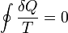
That means the line integral 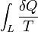is path independent.
So we can define a state function S called entropy, which satisfies

With this we can only obtain the difference of entropy by integrating the above formula. To obtain the absolute value, we need the Third Law of Thermodynamics, which states that S=0 at absolute zero for perfect crystals.
For any irreversible process, since entropy is a state function, we can always connect the initial and terminal status with an imaginary reversible process and integrating on that path to calculate the difference in entropy.
Now reverse the reversible process and combine it with the said irreversible process. Applying Clausius inequality on this loop,
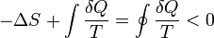
Thus,
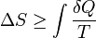
where the equality holds if the transformation is reversible.
Notice that if the process is an adiabatic process, then δQ = 0, so .

